**Practical No. 02**

**Introduction to ASP.NET**

**Aim: To demonstrate the postback and crosspage posting, basic and advanced asp controls, Angular JS, JQuery, NodeJS and Master Page – Content page using ASP.Net web application.**

**Q.1. Create college website using master page concept.**

**Code:**

**SiteCollege.Master**

<%@ Master Language="C#" AutoEventWireup="true" CodeBehind="SiteCollege.master.cs" Inherits="DemoCollegeMaster.SiteCollege" %>

<!DOCTYPE html>

<html>

<head runat="server">

<title></title>

<asp:ContentPlaceHolder ID="head" runat="server">

</asp:ContentPlaceHolder>

<style>

ul {

list-style-type: none;

margin: 0;

padding: 0;

overflow: hidden;

background-color: #333;

height: 53px;

}

li {

float: left;

}

li a {

display: block;

color: white;

text-align: center;

padding: 14px 16px;

text-decoration: none;

}

li a:hover {

background-color: #111;

}

</style>

</head>

<body style="margin:auto">

<ul>

<li><a class="active" href="WFContentHome.aspx">Home</a></li>

<li><a href="WFNews.aspx">News</a></li>

<li><a href="WFAbout.aspx">Contact</a></li>

</ul>

<form id="form1" runat="server" style="padding: 10px; margin: 10px">

<div>

<asp:ContentPlaceHolder ID="ContentPlaceHolder1" runat="server">

</asp:ContentPlaceHolder>

</div>

</form>

</body>

</html>

**WFContentHome.aspx**

<%@ Page Title="" Language="C#" MasterPageFile="~/SiteCollege.Master" AutoEventWireup="true" CodeBehind="WFContentHome.aspx.cs" Inherits="DemoCollegeMaster.WFContentHome" %>

<asp:Content ID="Content1" ContentPlaceHolderID="head" runat="server">

</asp:Content>

<asp:Content ID="Content2" ContentPlaceHolderID="ContentPlaceHolder1" runat="server">

<h1> Finolex Academy of Management and Technology (FAMT) </h1>

<br/>

<h2>FAMT is a reputed engineering institute situated on the picturesque coast of Ratnagiri, Maharashtra, India. It is affiliated with the University of Mumbai and offers undergraduate and postgraduate programs in engineering and technology.</h2>

<br/>

<p>

Here's a summary of what FAMT offers:

/p>

<p>

<b>Academics:</b><br/>

FAMT provides a comprehensive curriculum with programs in Computer Science & Engineering, Electrical Engineering, Electronics and Telecommunication, Information Technology, Mechanical Engineering, and Chemical Engineering. They also offer a Master of Computer Application (MCA) program.

Focus on Industry and Innovation: FAMT emphasizes practical training and industry collaboration to prepare students for successful careers. They have centers of excellence with partnerships like Microsoft Virtual Academy and Intel®

Infrastructure and Facilities: The institute boasts a sprawling campus with well-equipped labs, workshops, libraries, and other amenities.

Student Life: FAMT offers a vibrant campus life with sports facilities and extracurricular activities.

</p>

</asp:Content>

**WFAbout.aspx**

<%@ Page Title="" Language="C#" MasterPageFile="~/SiteCollege.Master" AutoEventWireup="true" CodeBehind="WFAbout.aspx.cs" Inherits="DemoCollegeMaster.WFAbout" %>

<asp:Content ID="Content1" ContentPlaceHolderID="head" runat="server">

<style type="text/css">

.alignleft {

width: 916px;

height: 518px;

}

.size-thumbnail {

height: 263px;

width: 438px;

}

</style>

</asp:Content>

<asp:Content ID="Content2" ContentPlaceHolderID="ContentPlaceHolder1" runat="server">

<div id="home" class="tab-pane fade in active">

<h3>About FAMT</h3>

</div>

</asp:Content>

**WFNews.aspx**

<%@ Page Title="" Language="C#" MasterPageFile="~/SiteCollege.Master" AutoEventWireup="true" CodeBehind="WFNews.aspx.cs" Inherits="DemoCollegeMaster.WFNews" %>

<asp:Content ID="Content1" ContentPlaceHolderID="head" runat="server">

<style type="text/css">

.auto-style1 {

text-decoration: underline;

}

</style>

</asp:Content>

<asp:Content ID="Content2" ContentPlaceHolderID="ContentPlaceHolder1" runat="server">

<p style="font-size: 24px">

<strong style="text-decoration: underline; font-style: italic; color: #0000FF">Here are a few ideas for news stories that FAMT (Finolex Academy of Management and Technology) could publish on their website (<span class="auto-style1">http://famt.ac.in/</span>) or social media channels:</strong></p>

<p>

<strong>Entrepreneurship Cell Activities:</strong> Publicize the activities of FAMT's entrepreneurship cell, such as workshops, incubation programs, or student startup success stories.

</p>

</asp:Content>

**Output:**

**Home Page**



**News Page**

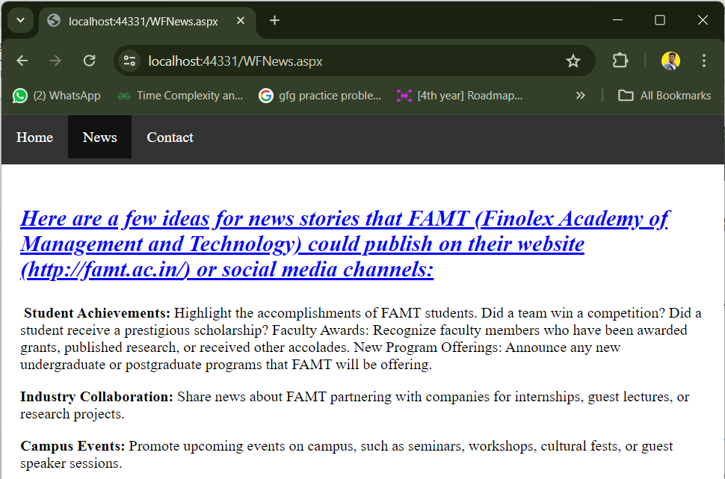

**About Page**

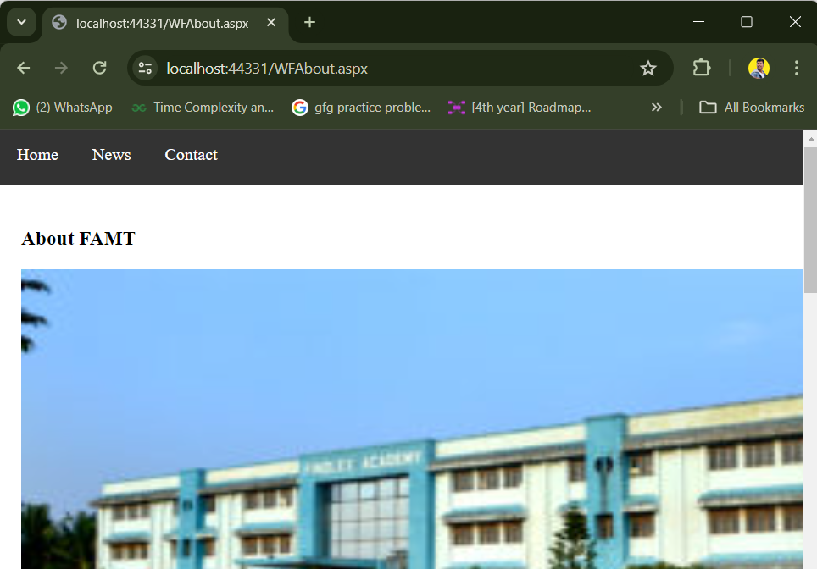

**Q.2. Design online shopping Website to demonstrate Master Pages and Theme page Concept.**

**Code:**

**MasterPage.Master**

<%@ Master Language="C#" AutoEventWireup="true" CodeBehind="MasterDemo.master.cs" Inherits="DEMOApplication.MasterDemo" %>

<!DOCTYPE html>

<html>

<head runat="server">

<meta charset="UTF-8" />

<meta http-equiv="X-UA-Compatible" content="IE=edge" />

<meta name="viewport" content="width=device-width, initial-scale=1.0" />

<title>Ecommerce website</title>

<link rel="stylesheet" href="style.css" />

<script

src="https://kit.fontawesome.com/0e53af926d.js"

crossorigin="anonymous"></script>

<asp:ContentPlaceHolder ID="head" runat="server">

</asp:ContentPlaceHolder>

</head>

<body>

<header>

<div id="header">

<div class="header-logo">

<a href="indext.html"><img src="images/logo.png" alt="" /></a>

</div>

<div class="header-list">

<nav class="header-list-nav">

<ul>

<li><a href="WebForm1.aspx">Home</a></li>

<li><a href="WebForm2.aspx">Products</a></li>

<li><a href="WebForm3.aspx">Prices</a></li>

<li><a href="WebForm4.aspx">Banners</a></li>

<li><a href="WebForm5.aspx">News</a></li>

</ul>

</nav>

<div class="header-list-icon">

<a href="WebForm1.aspx"><i class="fa fa-bag-shopping"></i></a>

</div>

</div>

</div>

</header>

<form id="form1" runat="server">

<div>

<asp:ContentPlaceHolder ID="ContentPlaceHolder1" runat="server">

</asp:ContentPlaceHolder>

</div>

</form>

<footer>

<div id="footer">

<div class="contact">

<a href="indext.html"><img src="images/logo.png" alt="" /></a>

<br> <br>

<br>

<h3>Contact</h3>

<address>

<p><b>Address:</b> Wellington Road, Street 32. San Francisco</p>

<p><b>Phone:</b> Wellington Road, Street 32. San Francisco</p>

<p><b>Hours</b> 10:00 - 18:00. Mon - Sat</p>

</address>

<h3>Follow Us</h3>

<br>

<div class="socials">

<a href="#"><i class="fa-brands fa-facebook-square"></i></a>

<a href="#"><i class="fa-brands fa-youtube"></i></a>

<a href="#"><i class="fa-brands fa-telegram"></i></a>

<a href="#"><i class="fa-brands fa-instagram"></i></a>

<a href="#"><i class="fa-brands fa-twitter"></i></a>

</div>

</div>

<div class="about">

<h3>About</h3>

<br>

<a href="#">About Us</a>

<a href="#">Delivery Information</a>

<a href="#">Privacy Policy</a>

<a href="#">Terms & Conditions</a>

<a href="#">Contact Us</a>

</div>

<div class="myaccount ">

<h3>My account</h3>

<br>

<a href="#">Sign In</a>

<a href="#">View Cart</a>

<a href="#">My Wishlist</a>

<a href="#">Track My Order</a>

<a href="#">Help</a>

</div>

<div class="install">

<h3>Install App</h3>

<br>

<p>From App Store or Google Play</p>

<div class="download">

<a href="#"><img src="images/pay/app.jpg" alt=""></a>

<a href="#"><img src="images/pay/play.jpg" alt=""></a>

</div>

<p>Secured Payment Gateways</p>

<img src="images/pay/pay.png" alt="">

</div>

</div>

</footer>

<script src="script.js"></script>

</body>

</html>

**WebForm1.aspx**

<%@ Page Title="" Language="C#" MasterPageFile="~/MasterDemo.Master" AutoEventWireup="true" CodeBehind="WebForm1.aspx.cs" Inherits="DEMOApplication.WebForm1" %>

<asp:Content ID="Content1" ContentPlaceHolderID="head" runat="server">

</asp:Content>

<asp:Content ID="Content2" ContentPlaceHolderID="ContentPlaceHolder1" runat="server">

<section id="hero">

<h4>Trade-in-offer</h4>

<h2>Super value deals</h2>

<h1>On all products</h1>

<p>save more coupons & up to 70% off!</p>

<button>Shop now</button>

</section>

<section id="features" class="section-p1">

<div class="f-box">

<img src="images/features/f1.png" alt="free shipping" />

<h6>Free shipping</h6>

</div>

<div class="f-box">

<img src="images/features/f2.png" alt="online order" />

<h6>online order</h6>

</div>

<div class="f-box">

<img src="images/features/f3.png" alt="save money" />

<h6>save money</h6>

</div>

<div class="f-box">

<img src="images/features/f4.png" alt="promotions" />

<h6>promotions</h6>

</div>

<div class="f-box">

<img src="images/features/f5.png" alt="happy sell" />

<h6>happy sell</h6>

</div>

<div class="f-box">

<img src="images/features/f6.png" alt="24/7 support" />

<h6>24/7 support</h6>

</div>

</section>

</asp:Content>

**WebForm2.aspx**

<%@ Page Title="" Language="C#" MasterPageFile="~/MasterDemo.Master" AutoEventWireup="true" CodeBehind="WebForm2.aspx.cs" Inherits="DEMOApplication.WebForm2" %>

<asp:Content ID="Content1" ContentPlaceHolderID="head" runat="server">

</asp:Content>

<asp:Content ID="Content2" ContentPlaceHolderID="ContentPlaceHolder1" runat="server">

<section class="product-section" class="section-p1">

<h1>Featured Products</h1>

<p>Summer Collection New Morden Design</p>

<div class="pro-collection">

<div class="product-cart">

<img src="images/products/f1.jpg" alt="product image" />

<span>adidas</span>

<h4>Cartoon Astronaut T-Shirts</h4>

<div class="stars">

<i class="fa-solid fa-star"></i>

<i class="fa-solid fa-star"></i>

<i class="fa-solid fa-star"></i>

<i class="fa-solid fa-star"></i>

<i class="fa-solid fa-star"></i>

</div>

<h4 class="price">$78</h4>

<a href="#"><i class="fa-solid fa-cart-shopping buy-icon"></i></a>

</div>

<div class="product-cart">

<img src="images/products/f2.jpg" alt="product image" />

<span>adidas</span>

<h4>Cartoon Astronaut T-Shirts</h4>

<div class="stars">

<i class="fa-solid fa-star"></i>

<i class="fa-solid fa-star"></i>

<i class="fa-solid fa-star"></i>

<i class="fa-solid fa-star"></i>

<i class="fa-solid fa-star"></i>

</div>

<h4 class="price">$78</h4>

<a href="#"><i class="fa-solid fa-cart-shopping buy-icon"></i></a>

</div>

<div class="product-cart">

<img src="images/products/f3.jpg" alt="product image" />

<span>adidas</span>

<h4>Cartoon Astronaut T-Shirts</h4>

<div class="stars">

<i class="fa-solid fa-star"></i>

<i class="fa-solid fa-star"></i>

<i class="fa-solid fa-star"></i>

<i class="fa-solid fa-star"></i>

<i class="fa-solid fa-star"></i>

</div>

<h4 class="price">$78</h4>

<a href="#"><i class="fa-solid fa-cart-shopping buy-icon"></i></a>

</div>

<div class="product-cart">

<img src="images/products/f4.jpg" alt="product image" />

<span>adidas</span>

<h4>Cartoon Astronaut T-Shirts</h4>

<div class="stars">

<i class="fa-solid fa-star"></i>

<i class="fa-solid fa-star"></i>

<i class="fa-solid fa-star"></i>

<i class="fa-solid fa-star"></i>

<i class="fa-solid fa-star"></i>

</div>

<h4 class="price">$78</h4>

<a href="#"><i class="fa-solid fa-cart-shopping buy-icon"></i></a>

</div>

<div class="product-cart">

<img src="images/products/f5.jpg" alt="product image" />

<span>adidas</span>

<h4>Cartoon Astronaut T-Shirts</h4>

<div class="stars">

<i class="fa-solid fa-star"></i>

<i class="fa-solid fa-star"></i>

<i class="fa-solid fa-star"></i>

<i class="fa-solid fa-star"></i>

<i class="fa-solid fa-star"></i>

</div>

<h4 class="price">$78</h4>

<a href="#"><i class="fa-solid fa-cart-shopping buy-icon"></i></a>

</div>

<div class="product-cart">

<img src="images/products/f6.jpg" alt="product image" />

<span>adidas</span>

<h4>Cartoon Astronaut T-Shirts</h4>

<div class="stars">

<i class="fa-solid fa-star"></i>

<i class="fa-solid fa-star"></i>

<i class="fa-solid fa-star"></i>

<i class="fa-solid fa-star"></i>

<i class="fa-solid fa-star"></i>

</div>

<h4 class="price">$78</h4>

<a href="#"><i class="fa-solid fa-cart-shopping buy-icon"></i></a>

</div>

<div class="product-cart">

<img src="images/products/f7.jpg" alt="product image" />

<span>adidas</span>

<h4>Cartoon Astronaut T-Shirts</h4>

<div class="stars">

<i class="fa-solid fa-star"></i>

<i class="fa-solid fa-star"></i>

<i class="fa-solid fa-star"></i>

<i class="fa-solid fa-star"></i>

<i class="fa-solid fa-star"></i>

</div>

<h4 class="price">$78</h4>

<a href="#"><i class="fa-solid fa-cart-shopping buy-icon"></i></a>

</div>

<div class="product-cart">

<img src="images/products/f8.jpg" alt="product image" />

<span>adidas</span>

<h4>Cartoon Astronaut T-Shirts</h4>

<div class="stars">

<i class="fa-solid fa-star"></i>

<i class="fa-solid fa-star"></i>

<i class="fa-solid fa-star"></i>

<i class="fa-solid fa-star"></i>

<i class="fa-solid fa-star"></i>

</div>

<h4 class="price">$78</h4>

<a href="#"><i class="fa-solid fa-cart-shopping buy-icon"></i></a>

</div>

</div>

</section>

<section id="off-banner" class="section-m1">

<h4>Repaire Services</h4>

<h2>Up to 70% Off - All t-Shirts & Accessories</h2>

<button class="normal">Explore More</button>

</section>

</asp:Content>

**WebForm3.aspx**

<%@ Page Title="" Language="C#" MasterPageFile="~/MasterDemo.Master" AutoEventWireup="true" CodeBehind="WebForm3.aspx.cs" Inherits="DEMOApplication.WebForm3" %>

<asp:Content ID="Content1" ContentPlaceHolderID="head" runat="server">

</asp:Content>

<asp:Content ID="Content2" ContentPlaceHolderID="ContentPlaceHolder1" runat="server">

<section class="product-section" class="section-p1">

<h1>New Arrivals</h1>

<p>Summer Collection New Morden Design</p>

<div class="pro-collection">

<div class="product-cart">

<img src="images/products/n1.jpg" alt="product image" />

<span>adidas</span>

<h4>Cartoon Astronaut T-Shirts</h4>

<div class="stars">

<i class="fa-solid fa-star"></i>

<i class="fa-solid fa-star"></i>

<i class="fa-solid fa-star"></i>

<i class="fa-solid fa-star"></i>

<i class="fa-solid fa-star"></i>

</div>

<h4 class="price">$78</h4>

<a href="#"><i class="fa-solid fa-cart-shopping buy-icon"></i></a>

</div>

<div class="product-cart">

<img src="images/products/n2.jpg" alt="product image" />

<span>adidas</span>

<h4>Cartoon Astronaut T-Shirts</h4>

<div class="stars">

<i class="fa-solid fa-star"></i>

<i class="fa-solid fa-star"></i>

<i class="fa-solid fa-star"></i>

<i class="fa-solid fa-star"></i>

<i class="fa-solid fa-star"></i>

</div>

<h4 class="price">$78</h4>

<a href="#"><i class="fa-solid fa-cart-shopping buy-icon"></i></a>

</div>

<div class="product-cart">

<img src="images/products/n3.jpg" alt="product image" />

<span>adidas</span>

<h4>Cartoon Astronaut T-Shirts</h4>

<div class="stars">

<i class="fa-solid fa-star"></i>

<i class="fa-solid fa-star"></i>

<i class="fa-solid fa-star"></i>

<i class="fa-solid fa-star"></i>

<i class="fa-solid fa-star"></i>

</div>

<h4 class="price">$78</h4>

<a href="#"><i class="fa-solid fa-cart-shopping buy-icon"></i></a>

</div>

<div class="product-cart">

<img src="images/products/n4.jpg" alt="product image" />

<span>adidas</span>

<h4>Cartoon Astronaut T-Shirts</h4>

<div class="stars">

<i class="fa-solid fa-star"></i>

<i class="fa-solid fa-star"></i>

<i class="fa-solid fa-star"></i>

<i class="fa-solid fa-star"></i>

<i class="fa-solid fa-star"></i>

</div>

<h4 class="price">$78</h4>

<a href="#"><i class="fa-solid fa-cart-shopping buy-icon"></i></a>

</div>

<div class="product-cart">

<img src="images/products/n5.jpg" alt="product image" />

<span>adidas</span>

<h4>Cartoon Astronaut T-Shirts</h4>

<div class="stars">

<i class="fa-solid fa-star"></i>

<i class="fa-solid fa-star"></i>

<i class="fa-solid fa-star"></i>

<i class="fa-solid fa-star"></i>

<i class="fa-solid fa-star"></i>

</div>

<h4 class="price">$78</h4>

<a href="#"><i class="fa-solid fa-cart-shopping buy-icon"></i></a>

</div>

<div class="product-cart">

<img src="images/products/n6.jpg" alt="product image" />

<span>adidas</span>

<h4>Cartoon Astronaut T-Shirts</h4>

<div class="stars">

<i class="fa-solid fa-star"></i>

<i class="fa-solid fa-star"></i>

<i class="fa-solid fa-star"></i>

<i class="fa-solid fa-star"></i>

<i class="fa-solid fa-star"></i>

</div>

<h4 class="price">$78</h4>

<a href="#"><i class="fa-solid fa-cart-shopping buy-icon"></i></a>

</div>

<div class="product-cart">

<img src="images/products/n7.jpg" alt="product image" />

<span>adidas</span>

<h4>Cartoon Astronaut T-Shirts</h4>

<div class="stars">

<i class="fa-solid fa-star"></i>

<i class="fa-solid fa-star"></i>

<i class="fa-solid fa-star"></i>

<i class="fa-solid fa-star"></i>

<i class="fa-solid fa-star"></i>

</div>

<h4 class="price">$78</h4>

<a href="#"><i class="fa-solid fa-cart-shopping buy-icon"></i></a>

</div>

<div class="product-cart">

<img src="images/products/n8.jpg" alt="product image" />

<span>adidas</span>

<h4>Cartoon Astronaut T-Shirts</h4>

<div class="stars">

<i class="fa-solid fa-star"></i>

<i class="fa-solid fa-star"></i>

<i class="fa-solid fa-star"></i>

<i class="fa-solid fa-star"></i>

<i class="fa-solid fa-star"></i>

</div>

<h4 class="price">$78</h4>

<a href="#"><i class="fa-solid fa-cart-shopping buy-icon"></i></a>

</div>

</div>

</section>

</asp:Content>

**WebForm4.aspx**

<%@ Page Title="" Language="C#" MasterPageFile="~/MasterDemo.Master" AutoEventWireup="true" CodeBehind="WebForm4.aspx.cs" Inherits="DEMOApplication.WebForm4" Theme=”ThemeSkin.Skin”%>

<asp:Content ID="Content1" ContentPlaceHolderID="head" runat="server">

</asp:Content>

<asp:Content ID="Content2" ContentPlaceHolderID="ContentPlaceHolder1" runat="server">

<section id="banners" class="section-p1">

<div class="big-banners">

<div class="big-banners-1">

<h4>crazy deals</h4>

<h2>buy 1 get 1 free</h2>

<span>The best classic dress is on sale at coro</span>

<button class="banner-btn">Learn More</button>

</div>

<div class="big-banners-2">

<h4>spring/summer</h4>

<h2>upcomming season</h2>

<span>The best classic dress is on sale at cara</span>

<button class="banner-btn">Collection</button>

</div>

</div>

<div class="small-banners">

<div class="small-banners-1">

<h2>SEASONAL SALE</h2>

<h5>Winter Collection 50% Off</h5>

</div>

<div class="small-banners-2">

<h2>NEW FOOTWEAR COLLECTION</h2>

<h5>Spring/Summer 2022</h5>

</div>

<div class="small-banners-3">

<h2>T-SHIRTS</h2>

<h5>New Trendy Prints</h4>

</div>

</div>

</section>

</asp:Content>

**WebForm5.aspx**

<%@ Page Title="" Language="C#" MasterPageFile="~/MasterDemo.Master" AutoEventWireup="true" CodeBehind="WebForm5.aspx.cs" Inherits="DEMOApplication.WebForm5" %>

<asp:Content ID="Content1" ContentPlaceHolderID="head" runat="server">

</asp:Content>

<asp:Content ID="Content2" ContentPlaceHolderID="ContentPlaceHolder1" runat="server">

<section id="newsletter">

<div class="newsletter-text">

<h3>Sign Up For Newsletters</h3>

<h5>get e-mail updates about out latest shop and <span>special offers</span></h5>

</div>

<div class="form">

<input type="email" placeholder="Your email address" id="email-address-input">

<button>Sign Up</button>

</div>

</section>

</asp:Content>

**Output:**

**WebForm1.aspx**

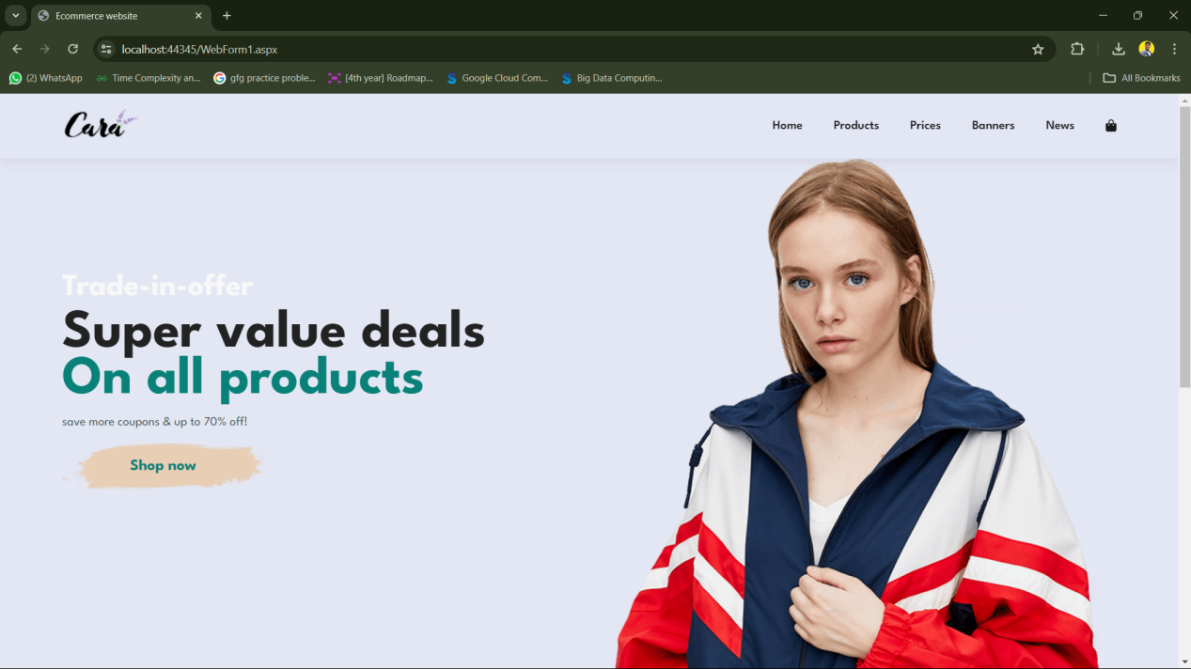

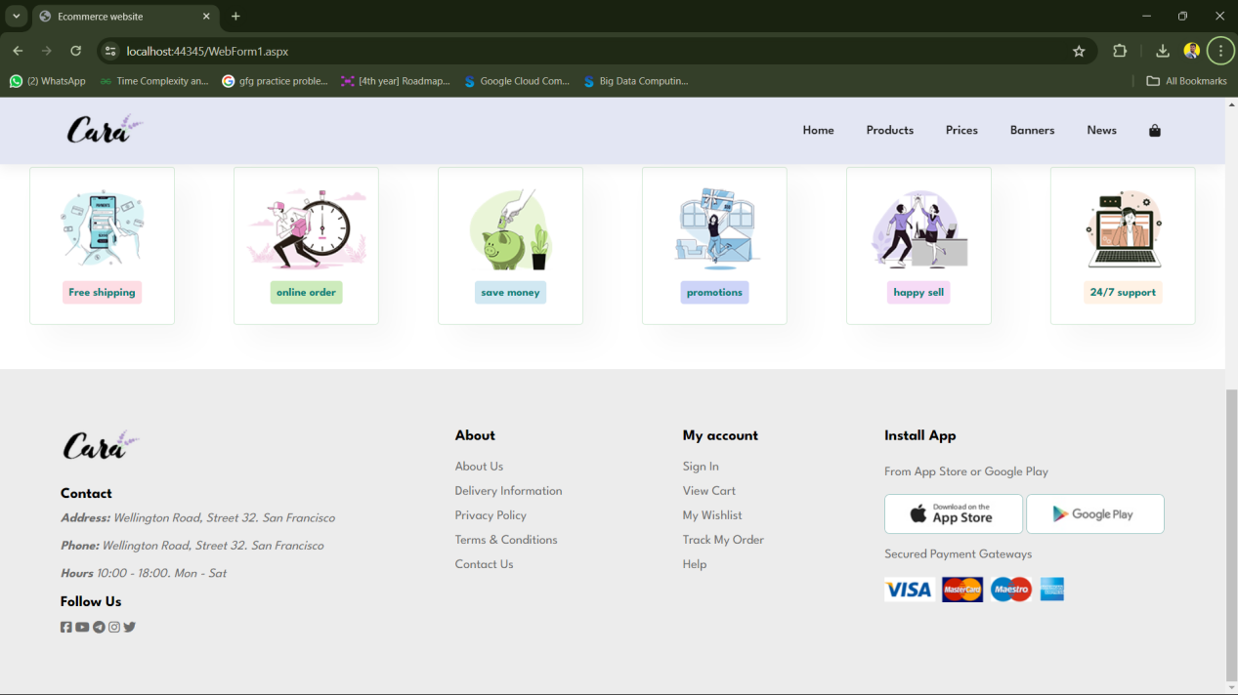

**WebForm2.aspx**

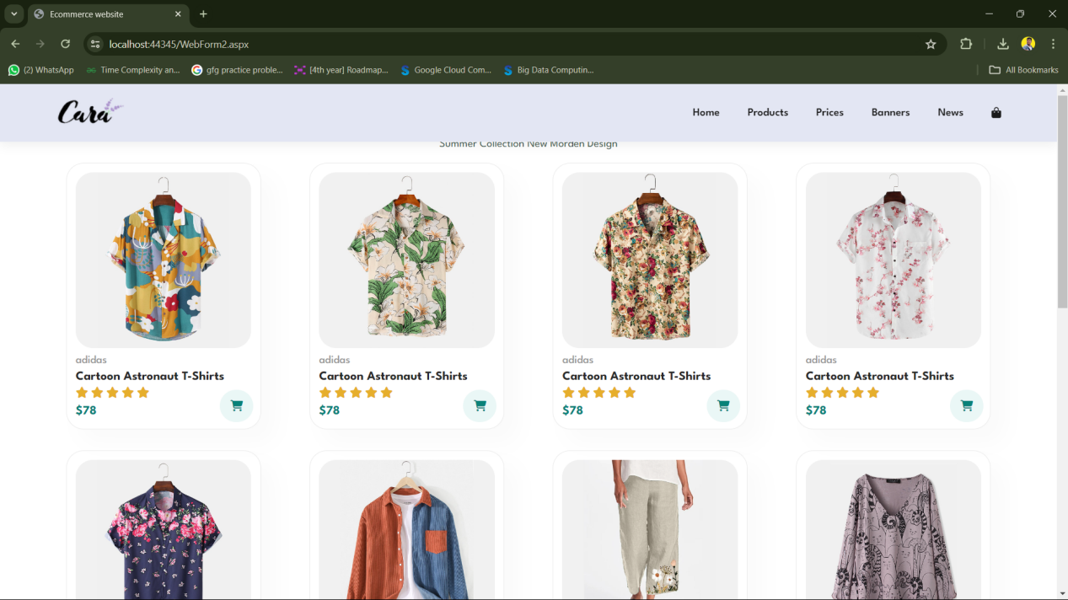

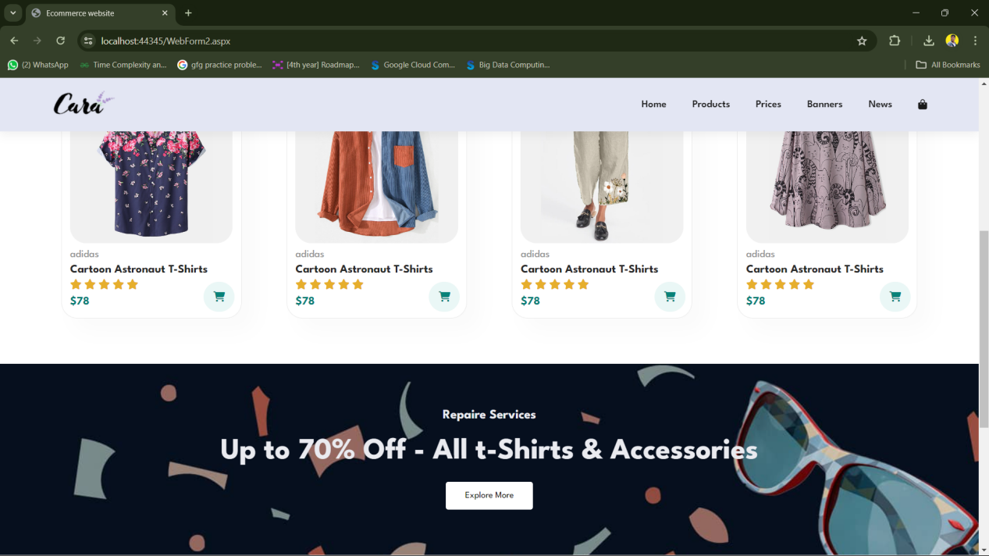

**WebForm3.aspx**

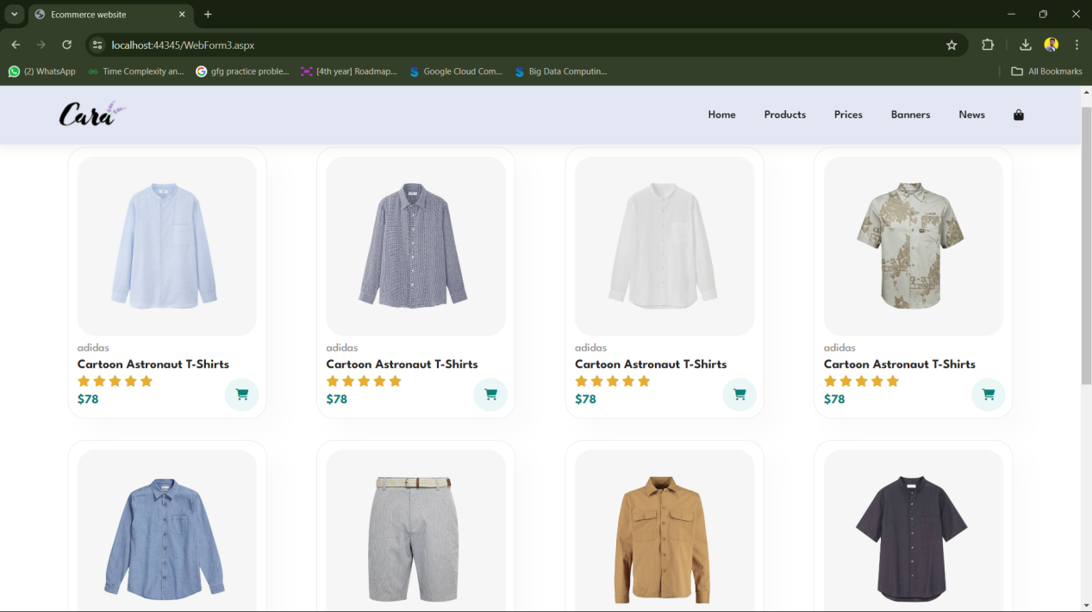

**WebForm4.aspx**

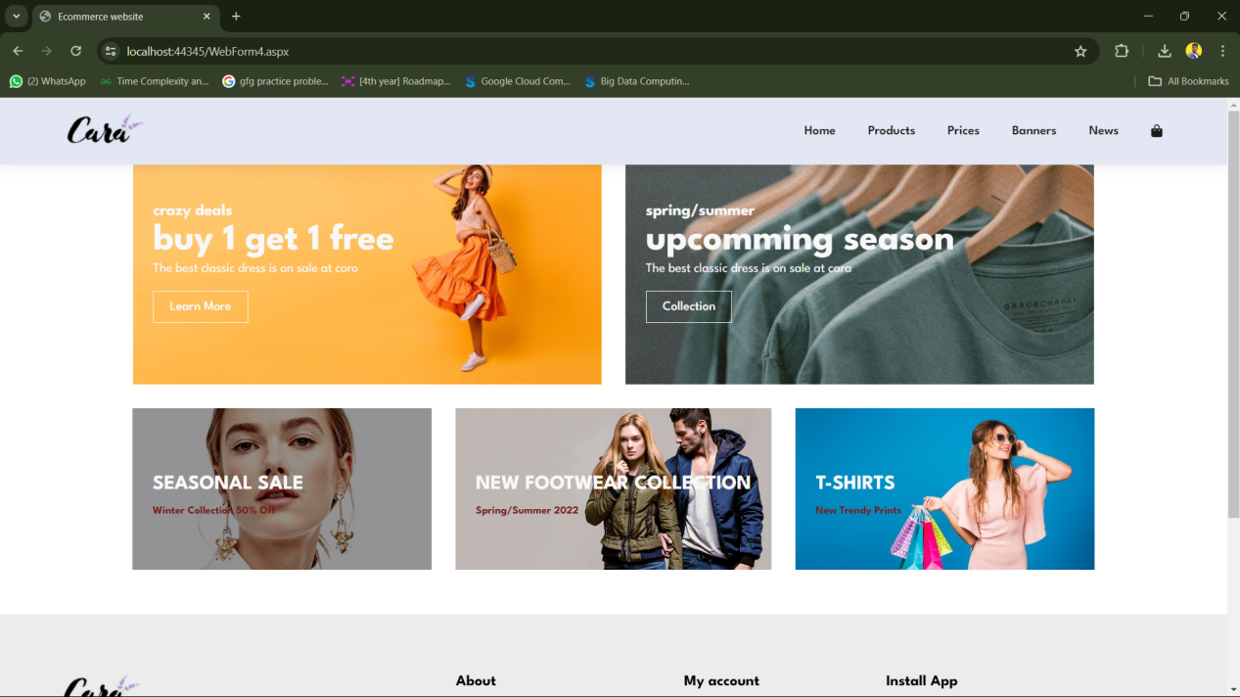

**ThemeSkin.Skin**

<%--

Default skin template. The following skins are provided as examples only.

1. Named control skin. The SkinId should be uniquely defined because

duplicate SkinId's per control type are not allowed in the same theme.

<asp:GridView runat="server" SkinId="gridviewSkin" BackColor="White" >

<AlternatingRowStyle BackColor="Blue" />

</asp:GridView>

2. Default skin. The SkinId is not defined. Only one default

control skin per control type is allowed in the same theme.

<asp:Image runat="server" ImageUrl="~/images/image1.jpg" />

--%>

<asp:button runat="server" BackColor="lightblue" ForeColor="black" />

**Q.3 Create a Web application as shown below using master page and validation controls.**

**Design:**

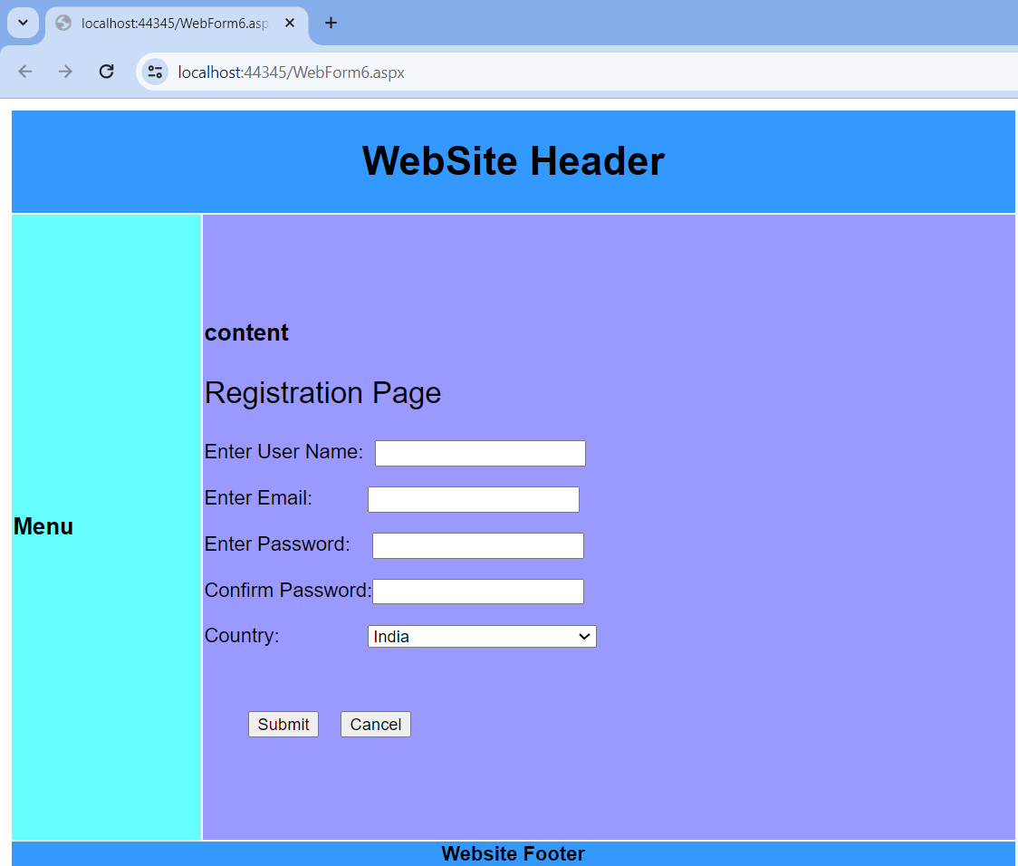

**Code:**

**MasterPage.Master**

<%@ Master Language="C#" AutoEventWireup="true" CodeBehind="MasterPage.master.cs" Inherits="DEMOApplication.MasterPage" %>

<!DOCTYPE html>

<html>

<head runat="server">

<title></title>

<asp:ContentPlaceHolder ID="head" runat="server">

</asp:ContentPlaceHolder>

</head>

<body>

<form id="form1" runat="server">

<table style="font-family:Arial">

<tr>

<td colspan="2" style="width:800px; height:80px; background-color:#3399FF;

text-align:center">

<h1>

WebSite Header

</h1>

</td>

</tr>

<tr>

<td style="height:500px; background-color:#66FFFF; width:150px">

<h3>Menu</h3>

</td>

<td style="height:500px; background-color:#9999FF; width:650px">

<h3>content</h3>

<div>

<asp:ContentPlaceHolder id="ContentPlaceHolder1" runat="server">

</asp:ContentPlaceHolder>

</div>

</td>

</tr>

<tr>

<td colspan="2" style="background-color:#3399FF; text-align:center">

<b>Website Footer</b>

</td>

</tr>

</table>

</form>

</body>

</html>

**WebForm6.aspx**

<%@ Page Title="" Language="C#" MasterPageFile="~/MasterPage.Master" AutoEventWireup="true" CodeBehind="WebForm6.aspx.cs" Inherits="DEMOApplication.WebForm6" %>

<asp:Content ID="Content1" ContentPlaceHolderID="head" runat="server">

</asp:Content>

<asp:Content ID="Content2" ContentPlaceHolderID="ContentPlaceHolder1" runat="server">

<p style="font-size: x-large">

Registration Page</p>

<p>

Enter User Name:&nbsp;

<asp:TextBox ID="TextBox1" runat="server"></asp:TextBox>

<asp:RequiredFieldValidator ID="RequiredFieldValidator1" runat="server" ControlToValidate="TextBox1" Display="Dynamic" ErrorMessage="RequiredFieldValidator" ForeColor="#CC0000">Please Enter User Name!!!</asp:RequiredFieldValidator>

</p>

<p>

Enter Email:&nbsp;&nbsp;&nbsp;&nbsp;&nbsp;&nbsp;&nbsp;&nbsp;&nbsp;

<asp:TextBox ID="TextBox2" runat="server"></asp:TextBox>

<asp:RegularExpressionValidator ID="RegularExpressionValidator1" runat="server" ControlToValidate="TextBox2" Display="Dynamic" ErrorMessage="Enter Proper Email" ForeColor="#CC0000" ValidationExpression="\w+([-+.']\w+)*@\w+([-.]\w+)*\.\w+([-.]\w+)*">Properly Enter E-Mail</asp:RegularExpressionValidator>

</p>

<p>

Enter Password:&nbsp;&nbsp;&nbsp;

<asp:TextBox ID="TextBox3" runat="server"></asp:TextBox>

<asp:RequiredFieldValidator ID="RequiredFieldValidator2" runat="server" ControlToValidate="TextBox3" Display="Dynamic" ErrorMessage="Required Password" ForeColor="#CC0000">Please Enter Password</asp:RequiredFieldValidator>

</p>

<p>

Confirm Password:<asp:TextBox ID="TextBox4" runat="server"></asp:TextBox>

<asp:CompareValidator ID="CompareValidator1" runat="server" ControlToCompare="TextBox3" ControlToValidate="TextBox4" Display="Dynamic" ErrorMessage="Password Not Match"></asp:CompareValidator>

</p>

<p>

Country:&nbsp;&nbsp;&nbsp;&nbsp;&nbsp;&nbsp;&nbsp;&nbsp;&nbsp;&nbsp;&nbsp;&nbsp;&nbsp;&nbsp;&nbsp;

<asp:DropDownList ID="DropDownList1" runat="server" Width="184px">

<asp:ListItem>India</asp:ListItem>

<asp:ListItem>USA</asp:ListItem>

<asp:ListItem>Germany</asp:ListItem>

<asp:ListItem>Sri Lanka</asp:ListItem>

</asp:DropDownList>

</p>

<p>

&nbsp;</p>

<p>

&nbsp;&nbsp;&nbsp;&nbsp;&nbsp;&nbsp;&nbsp;

<asp:Button ID="Button1" runat="server" Text="Submit" />

&nbsp;&nbsp;

<asp:Button ID="Button2" runat="server" Text="Cancel" />

</p>

</asp:Content>

**Output:**

